**HCIN 5405**

**Methodologies for Discrete Event Modeling and Simulation**

**Assignment2: Banded Vegetation Simulator**

Meagan Leflar

100742690

Carleton University

# Part 1: Conceptual Model

The purpose of this simulation is to examine the growth of banded vegetation in semi-arid and arid landscapes such as grasslands, shrublands, and woodlands based on the reception of constant rainfall. This differs from the other vegetation simulation in that it deals with constant rainfall as the only resource, and considers a different variety of vegetation, and seeks to understand a specific banding phenomenon. This simulation is based on “**Banded vegetation: development under uniform rainfall from a simple cellular automaton model**”, by D. L. Dunkerley (Department of Geography and Environmental Science at Monash University, Australia).

This model will be developed using a homogeneous cell-space that is 50 cells by 50 cells, and each cell represents a square meter plot of land (not simply one plant). A cell has two states: occupied by vegetation, or not occupied by vegetation. When the simulation begins, cells are randomly set to have vegetation or to not have plants within them. Each step forward in the simulation, 100mm of rainfall is distributed as an input to each cell. An empty cell will absorb 10% of the rainfall; the rest of the water is distributed evenly to the three cells downhill of the empty cell. Empty cells do not absorb any runoff water. Cells that are occupied by plants absorb 100% of the water they receive, and the absorbed water is distributed among its neighbours by the donor cell in the following way: 10% goes to the four neighbours that share an edge with the donor cell and the two cells that are diagonal and downhill of the donor cell, and 5% goes to the cells twice removed from the donor cell. Although the author of the paper this simulation is referencing had issues with borders, as cells on the edges did not receive water from all sides, this version of the simulation will be designed with this in mind and therefore this cell space will be wrapped.

A cell’s state will change based on the amount of water that they have, or the dampness of the soil. Dunkerley’s paper states that if the soil moisture is less than 1.2-3.5 (we have decided to go with 2.0 for the purpose of this simulation) times the annual rainfall of the area, then the vegetation will die off. Conversely, if the cell receives 0.6-1.2 (we have decided to go with 0.6 for the purpose of this simulation) times the annual rainfall of the area, then plants will be able to grow in that cell, so the state will change.

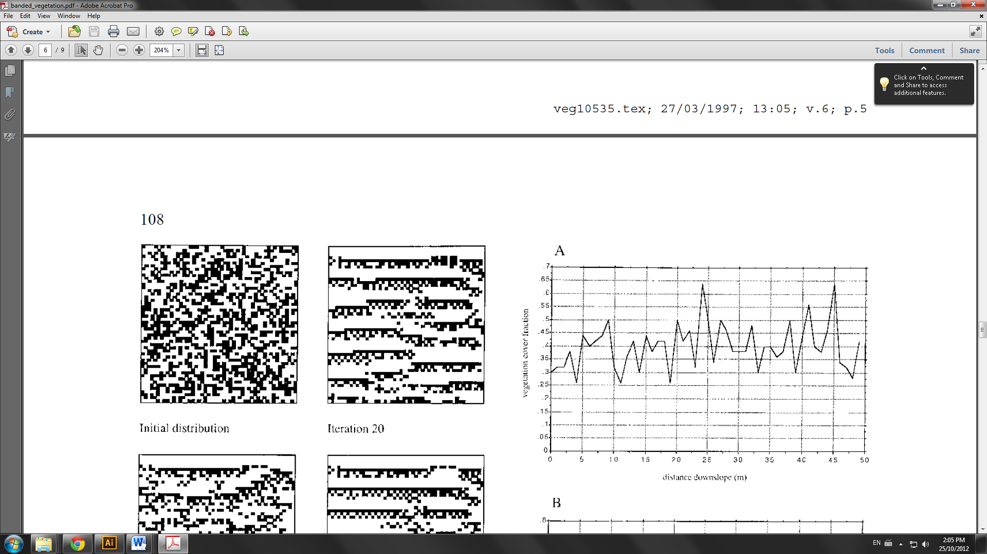**Figure 1: Diagram of the banding phenomenon that is expected to surface based on these parameters** (Taken from the reference paper)

# Part 2: Formal Specifications

VEG = < X, Y, I, S, θ, N, d, δint, δext, τ, λ, D >

X = {Ø}

Y = {Ø}

I = <ɳ, µ, Px, Py> //modular interface

ɳ = 25 //the neighborhood size

µ = 0 //number of other ports

Px = {all in neighbourhood}

Py = {all in neighbourhood}

S = {no plant, plant}

θ = {0: empty cell, 1: plant cell}

N = {Ø}

d = transport delay, 1000 milliseconds

τ = “update_rule” pseudo code

* If the cell is empty (S = 0)
  + **and** the value of primary neighbourhood cells (-1, 1) + (0, 1) + (1, 1) + (-1, 0) + (0, -1) + (1, 0) *//deals with absorption from directly beside cells*
  + **plus** the value of secondary neighbourhood cells ((-1, 2) + (0, 2) + (1, 2) + (-2, 1) + (-2, 0) + (2, 1) +(2, 0)) / 2 *//deals with absorption from applicable twice removed cells*
  + **Is greater than** 5 (absorbs 10% by default) *//for the purpose of calculations, 5 is 50%.*
  + Then the cell can grow a plant (S = 1).
* If the cell has a plant (S = 1)
  + **and** the value of primary neighbourhood cells (-1, 1) + (0, 1) + (1, 1,) + (-1, 0) + (0, -1) + (1, 0) *//deals with absorption from directly beside cells*
  + **plus** the value of secondary neighbourhood cells ((-1, 2) + (0, 2) + (1, 2) + (-2, 1) + (-2, 0) + (2, 1) +(2, 0)) / 2 *//deals with absorption from applicable twice removed cells*
  + **plus** 9 – (the value of ((-1, 1) + (0, 1) + (1, 1)) x3) *//deals with runoff water from uphill empty cells*
  + **Is less than** 10 (because original rainfall is initially absorbed)
  + Then the cell can no longer grow a plant (S = 0)
* Otherwise, the state remains the same.

# Part 3: Results

## 3.1 Starting State: Random

The first test was done as specified by the reference paper, using a random scattering of plants and empty cells. This is the set up that is in the MA file submitted.

**Figure 2: Starting and ending states of the simulation with random distribution**

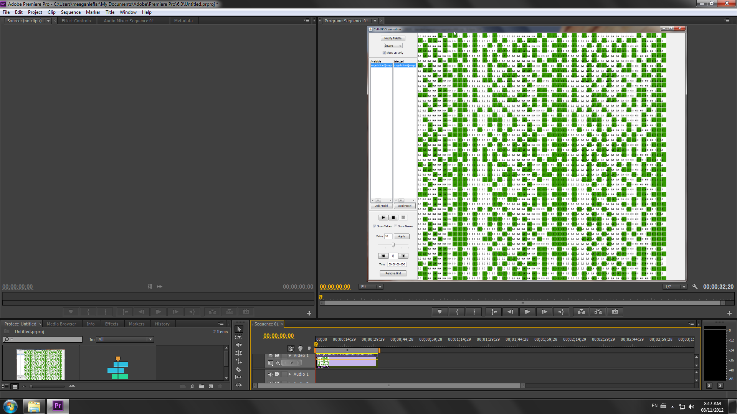 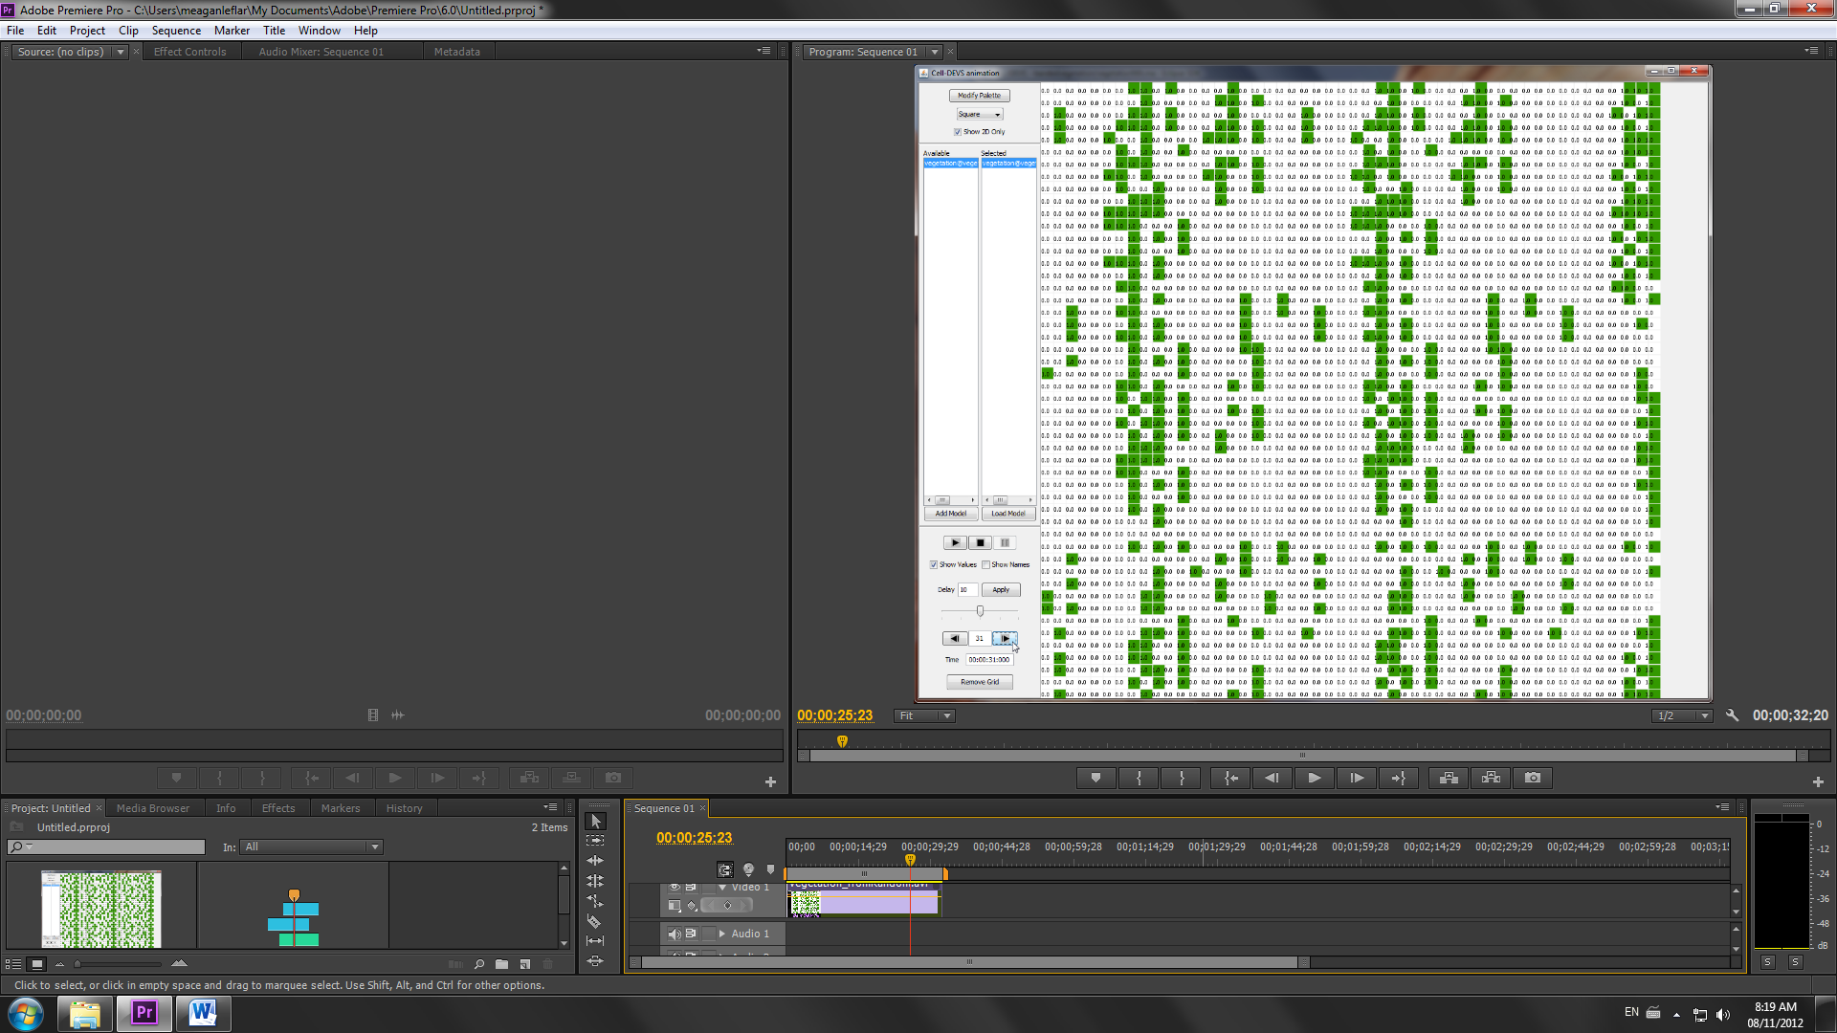

When the simulation ran, similar results were acquired as were demonstrated in the reference paper. The biggest difference being that this version of the simulation was programmed with downhill being to the left, instead of towards the bottom of the screen. Besides this, the results are similar. Additionally, the “randomly generates” values in this example where done by hand. This may affect the simulation slightly, but the banding phenomenon exhibited here reoccurs in the other scenarios described in this section. This simulation can be watched in vegetation_fromRandom.avi.

## 3.2 Starting State: Lines

The second test executed explored a different starting vegetation state. In this test, the vegetation already exists in bands.

**Figure 3: Starting and ending states of the simulation with banded distribution**

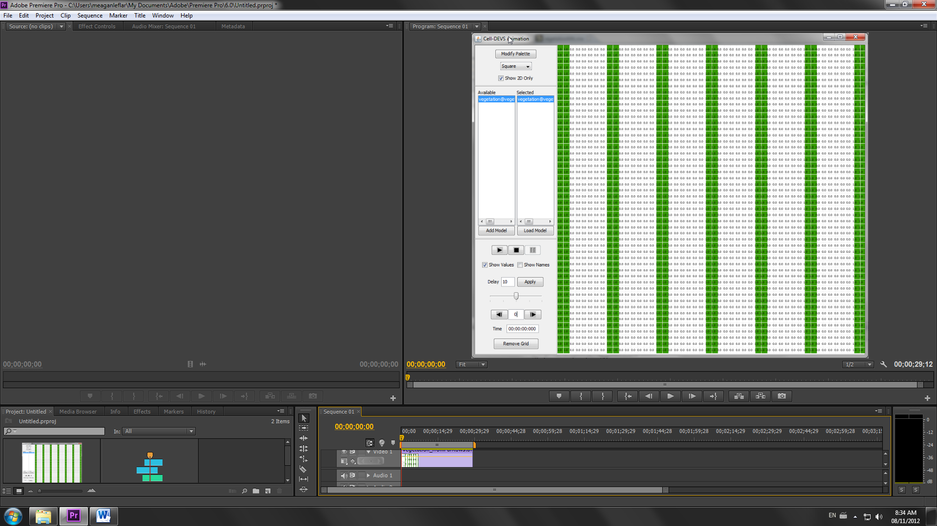 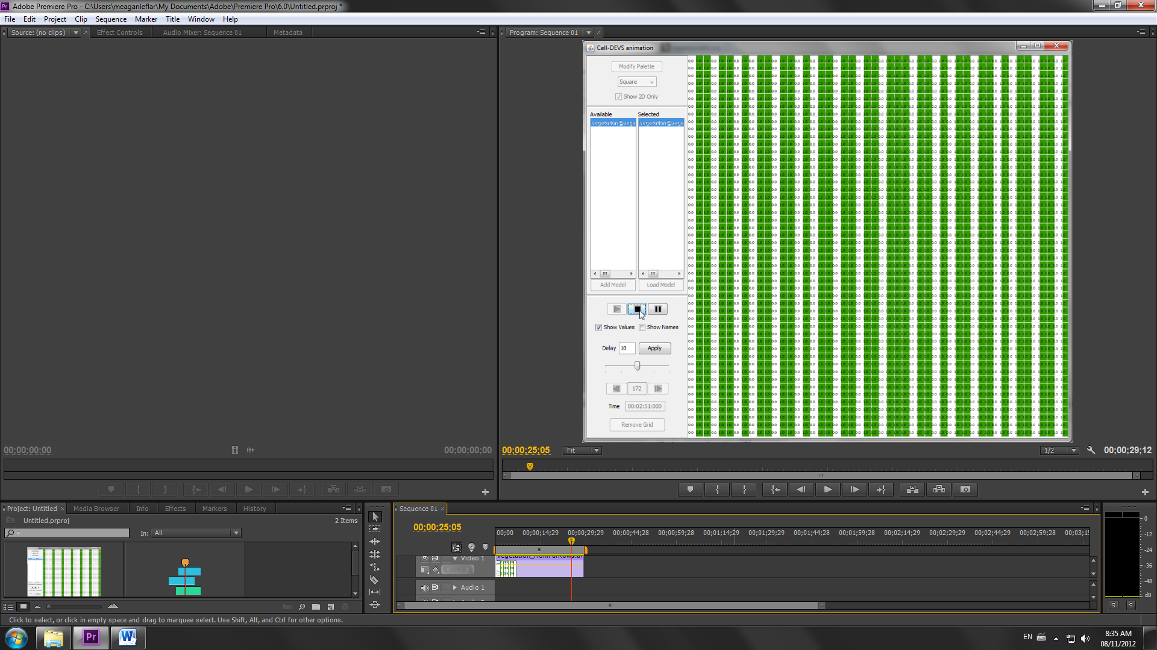

In this case, the banding phenomenon was maintained, but the plant life grew more plentiful instead of more sparse, demonstrating that this genre of vegetation system works well in a banded state. Also, if the video taken of this simulation is observed (vegetation_fromFarRows.avi), one can see how the vegetation spreads downhill.

**Figure 4: Screen captures from vegetation_fromFarRows.avi demonstrating downhill movement**

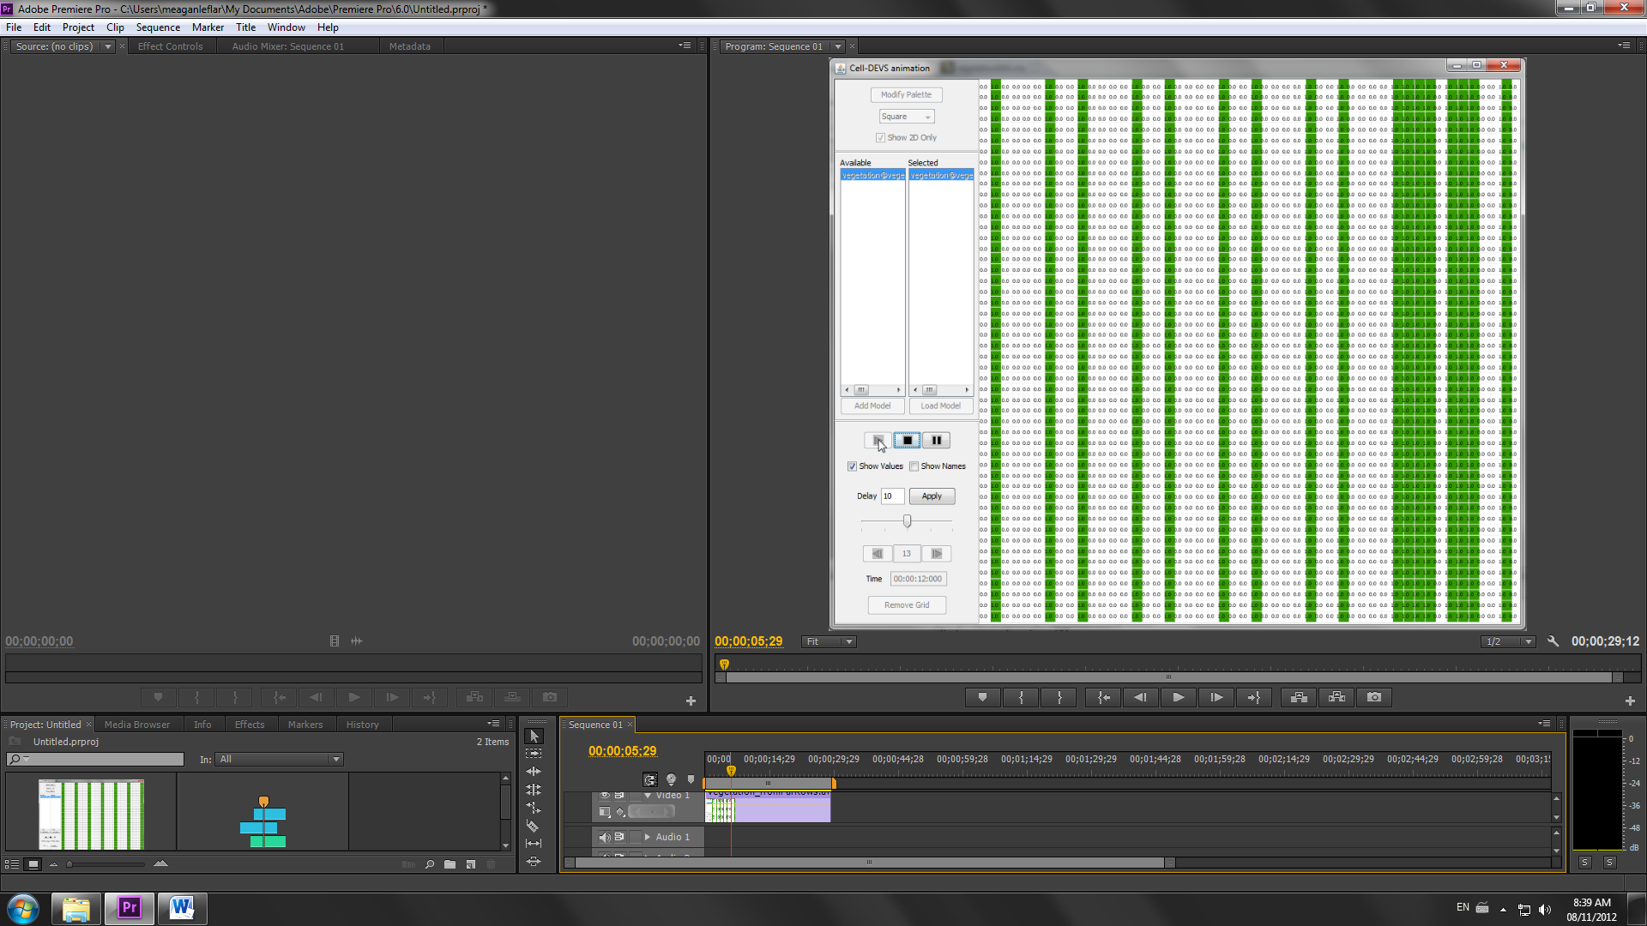 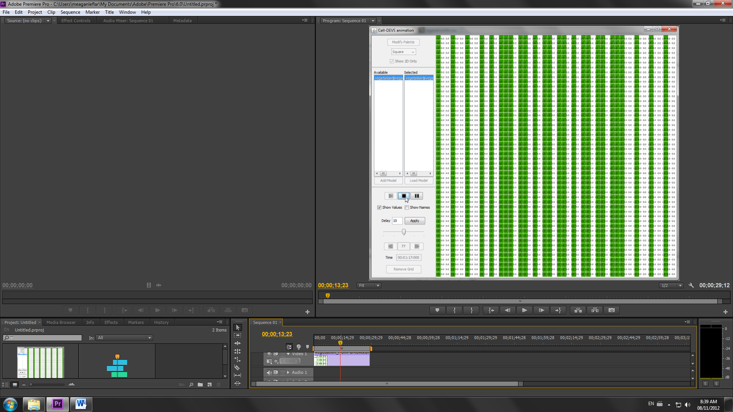

Another potential reason for the vegetation becoming more plentiful in this simulation is that the reference paper does not describe a rule for plants that get “too much” water. This will be explored slightly more in depth in section 3.6.

## 3.3 Starting State: Alternating

The third simulation was run based on an alternating design, and can be watched in vegetation_fromsemiStripes.avi.

**Figure 5: Starting and ending points of simulation run from an alternating distribution**

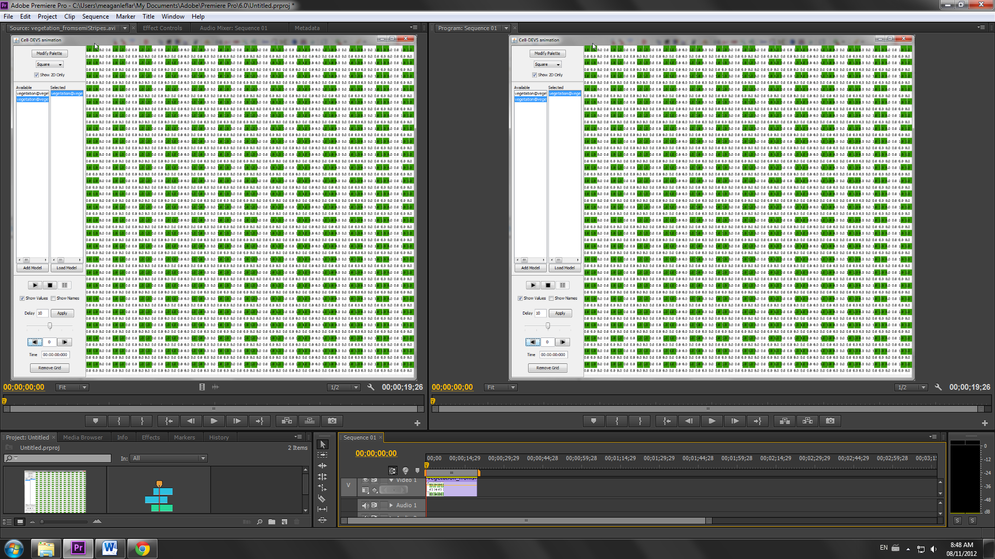 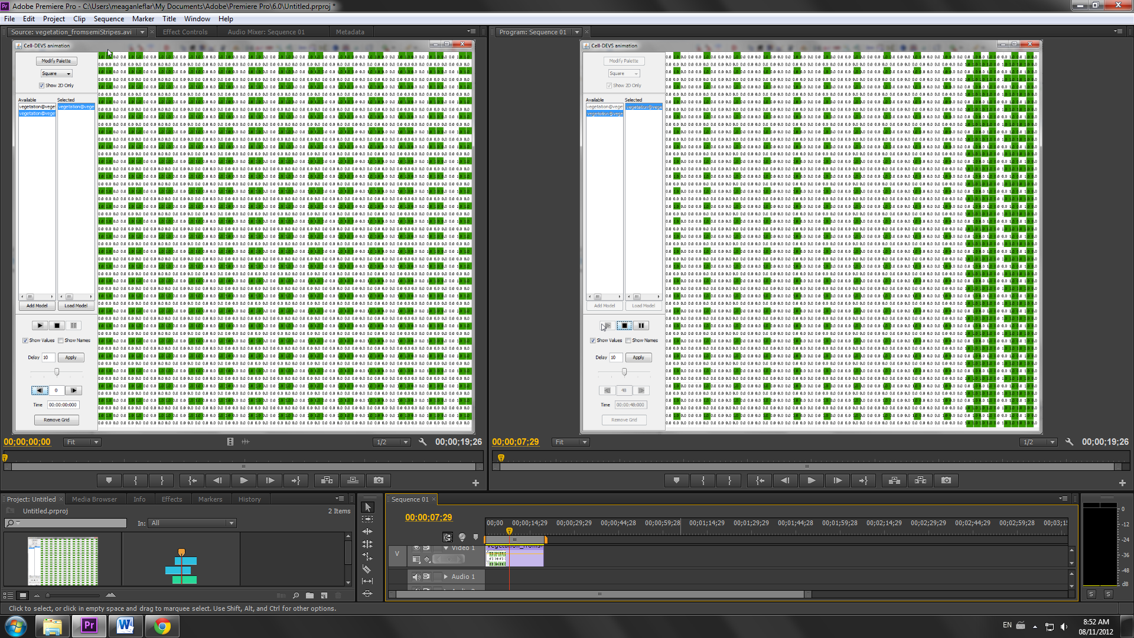

In this simulation, the banding phenomenon continues to be exhibited. In this case, the simulation ended with two thicker bands on the right side of the grid because this model has wrapped borders and the two chunks of plants on the far left and far right were connected when the simulation began. It would seem that plants would rather have bands of just one plant instead of bands of several (this was also observed in section 3.2’s simulation).

## 3.4 Starting State: Spot

The fourth simulation was run starting with a collection of plants at the center of the simulation space. This simulation can be watched in vegetation_fromSpot.avi.

**Figure 6: Starting and ending points of simulation run from a collection of plants in center**

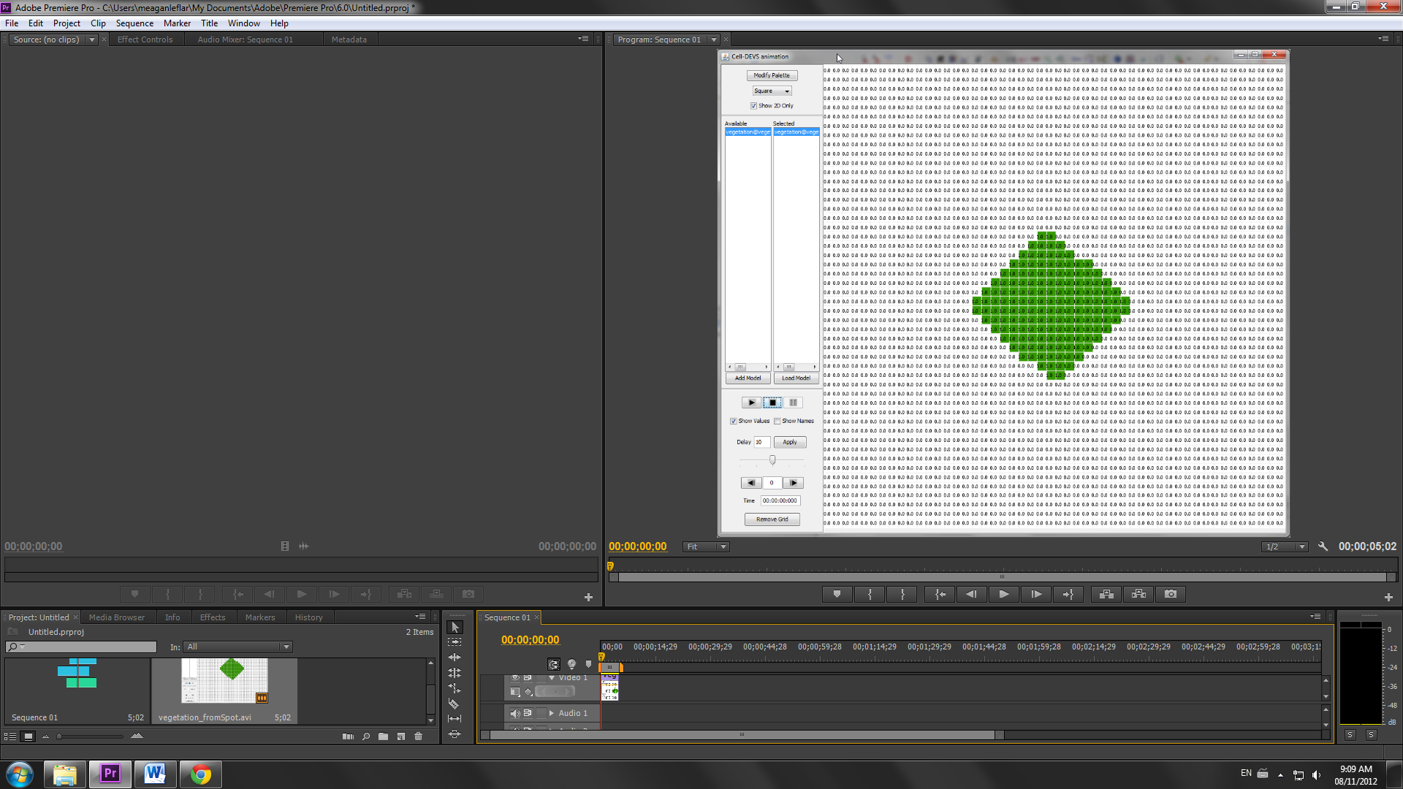 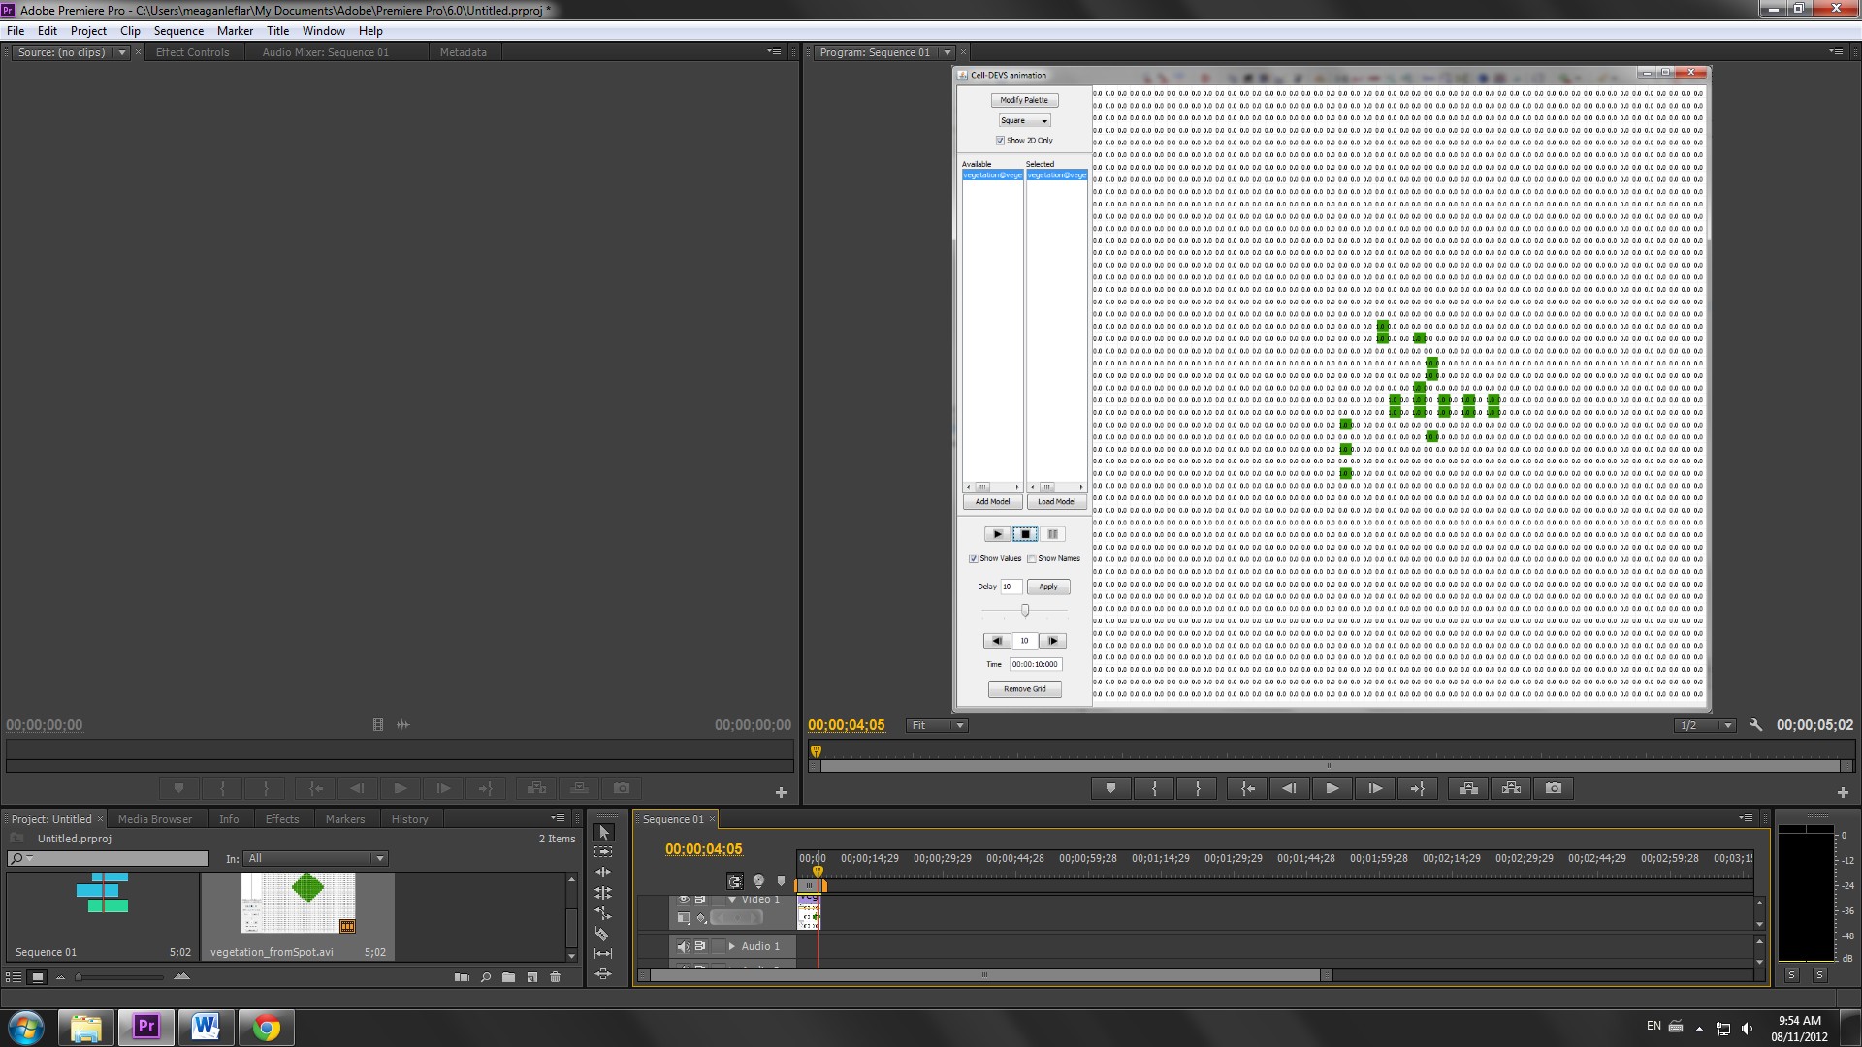

In this simulation, the banding phenomenon occurs again, with one vertical space between “bands”, though it is harder to see. It is also becomes evident that where there are no plants, plants are not likely to begin growing.

## 3.4 Starting State: Pattern

Just to see what would happen, this simulation began with a star pattern. This simulation can been viewed in the video vegetation_fromPattern.avi.

**Figure 7: Starting and ending points of simulation run from star pattern**

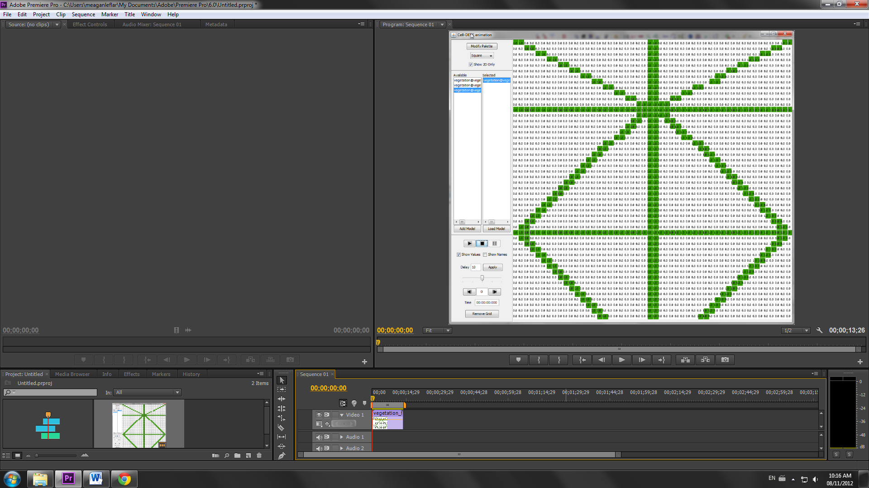 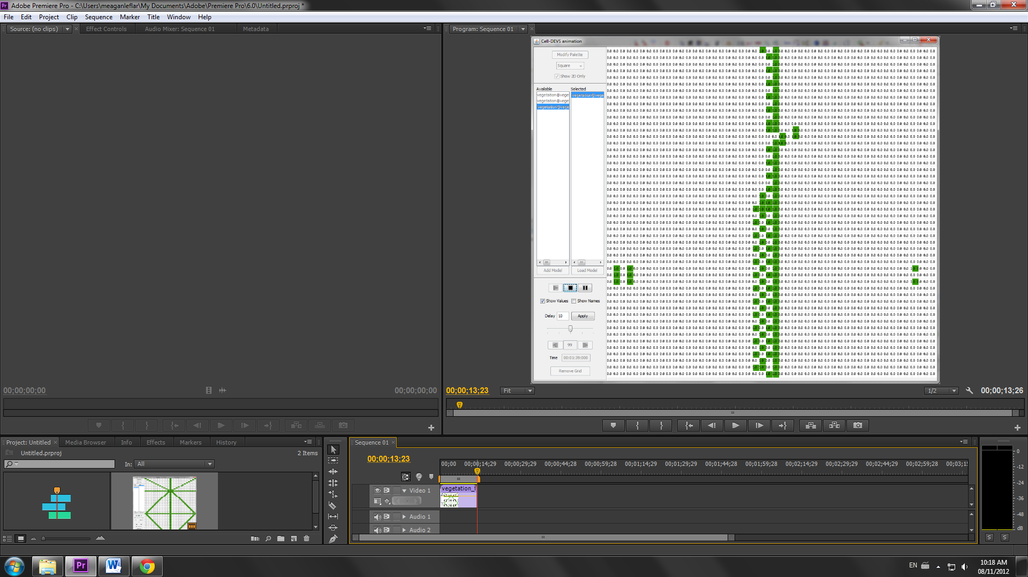

Where there were enough plants, banding occurred. Where plants were too scarce, they all died off.

## 3.6 Starting State: Half Full

The sixth simulation was run starting with half of the grid (the uphill half) filled with plants, and the lower half empty of plants. To best see how this simulation progressed, please watch the video vegetation_fromTop.avi.

**Figure 8: Starting and ending points of simulation run from the top half of the grid being full**

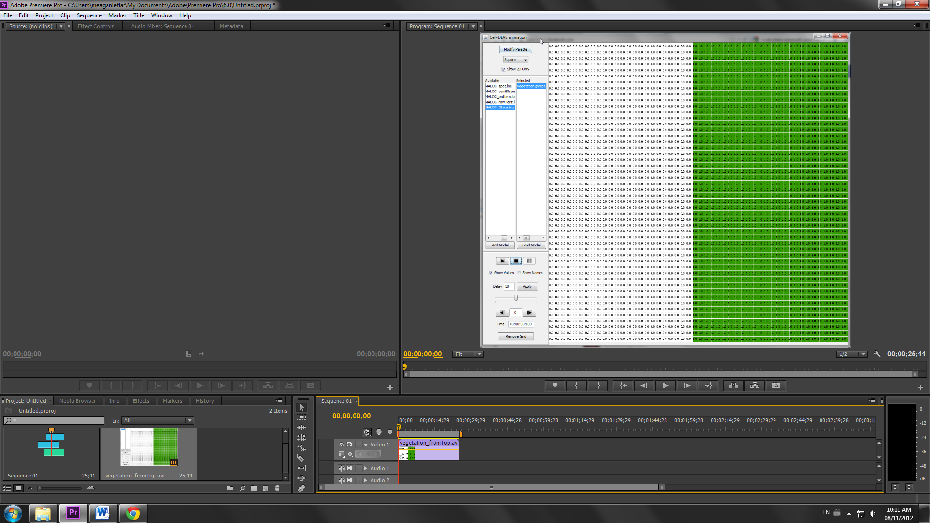 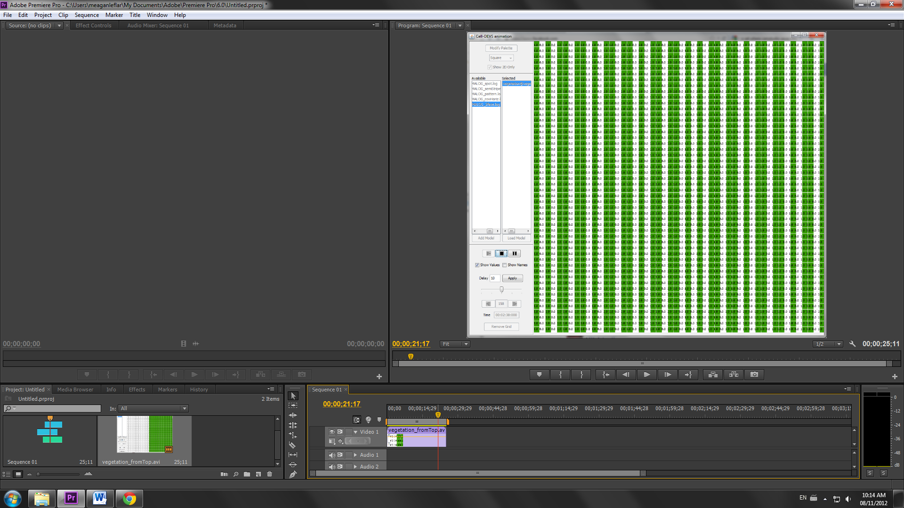

In this simulation, the plants spread out downhill until they end up creating a banded strucutre, as shown above. I think this simulation, more than all the others, clearly demonstrate the two key parts of this model: that the water is shared heavily downhill, and that the plants will create bands of growth.

As mentioned in section 3.2, I decided to implement an additional rule just to test. This rule would come into effect if the plants get too much water to live. However, this did not seem to change the simulation results. The updated version of the half full simulation is called vegetation_newRule.avi.